WELCOME

# SMS WEB APPLICATION

A web application in which we get features to send otp(a random 6 digit number) to given a number.

1)Some dummy Contact

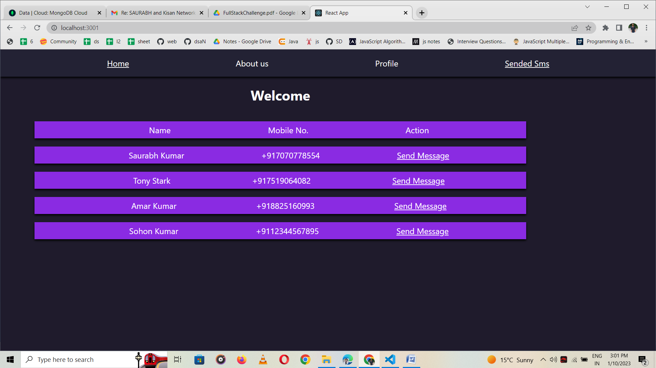

2) Otp sending Button on selected contact

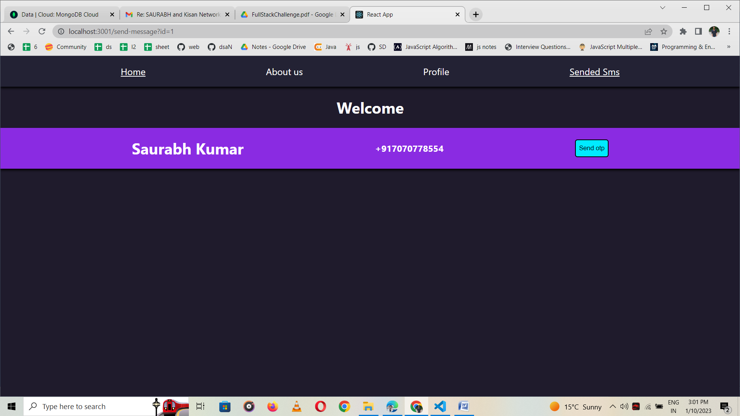

3) List of otp recived people

